|  |
| --- |
| CS 524 Introduction to Cloud Computing |
| Dharmit Viradia |
| Lab Assignment 3 |
| Prof. Igor Faynberg |

**Step for Creating an S3 Bucket**

* First login in to your AWS account

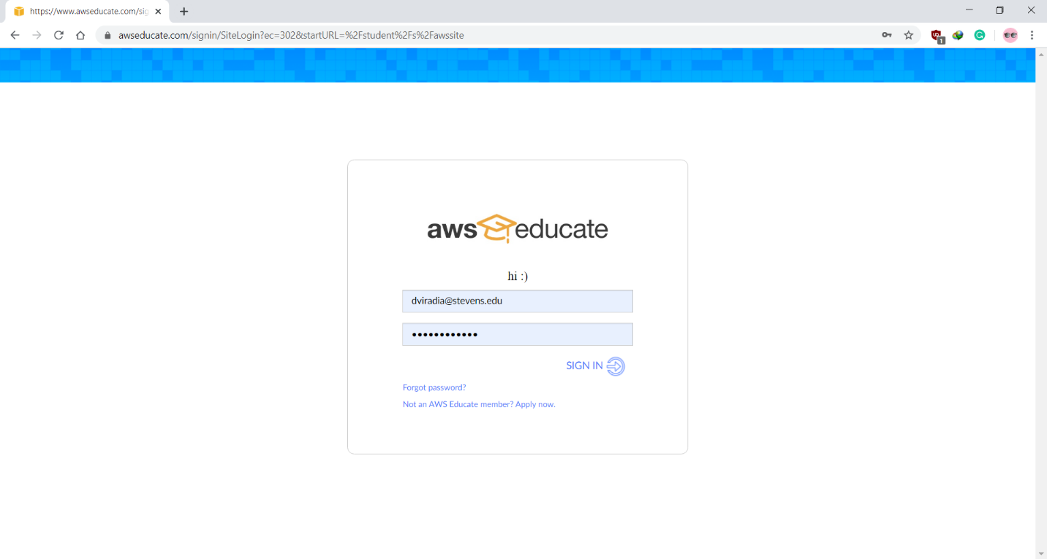

* On AWS Dashboard go to S3 Services

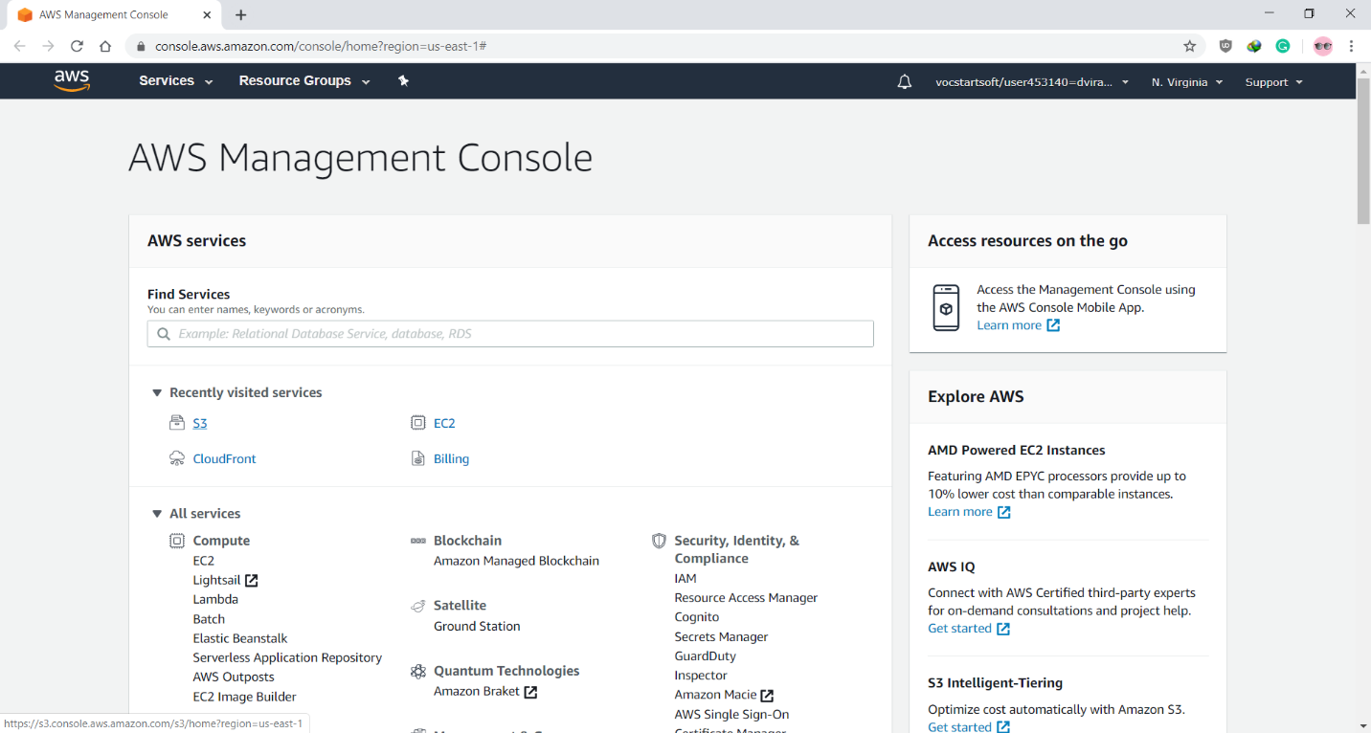

* On S3 bucket Dashboard create new bucket

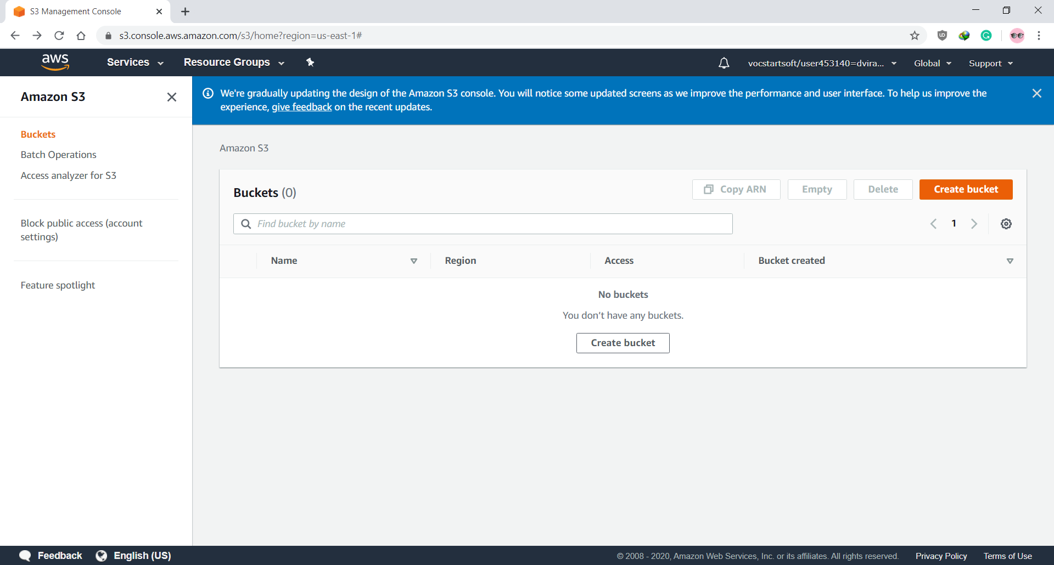

* Give the unique name to your bucket

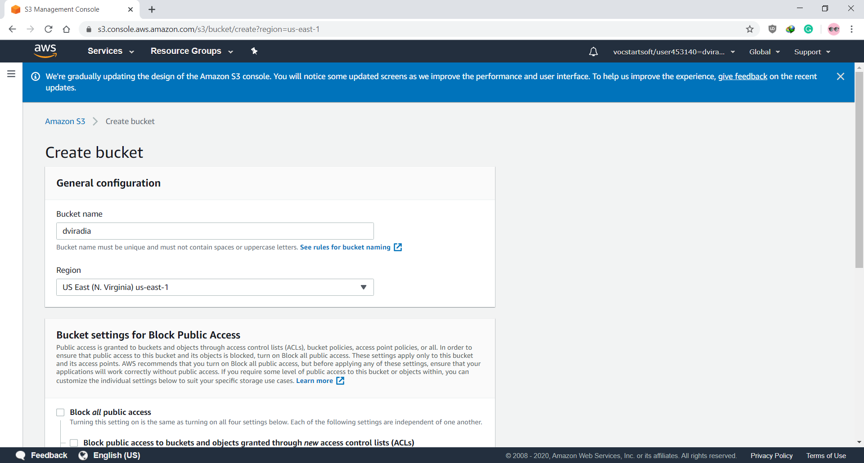

* Turn off the Block all public access

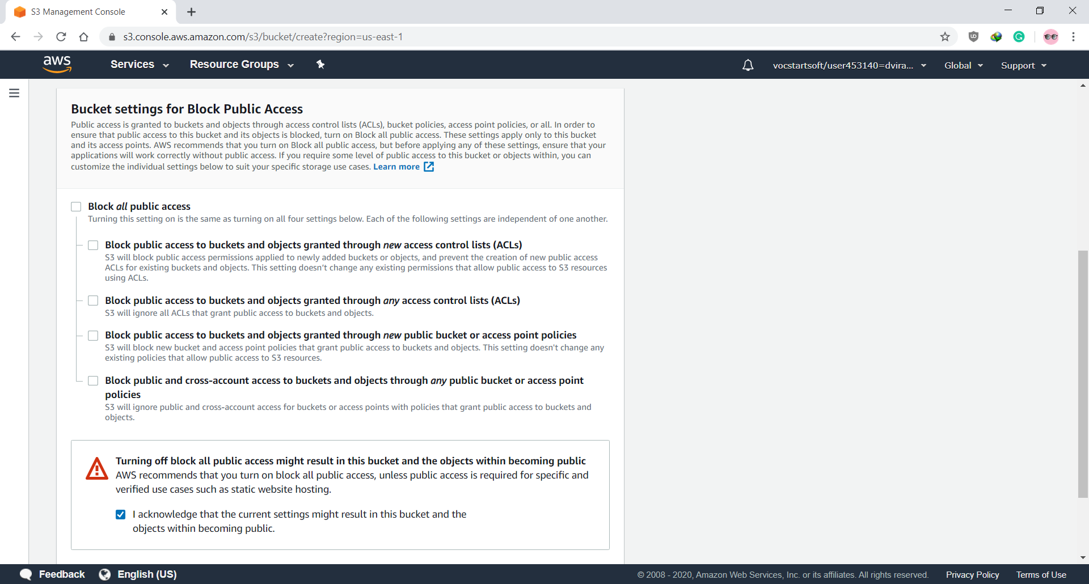

* After Bucket is created successfully it shows on dashboard

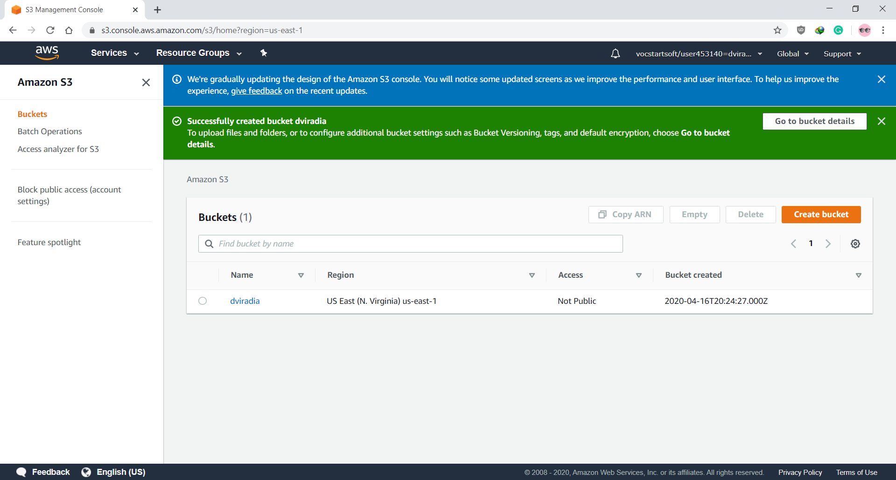

* Click on Bucket name to view bucket and upload an image of your choice.

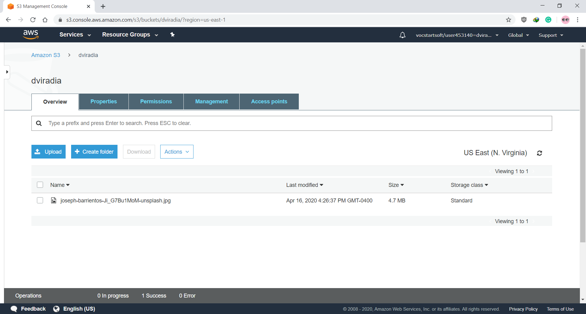

* After the images is uploaded update permission for public view access

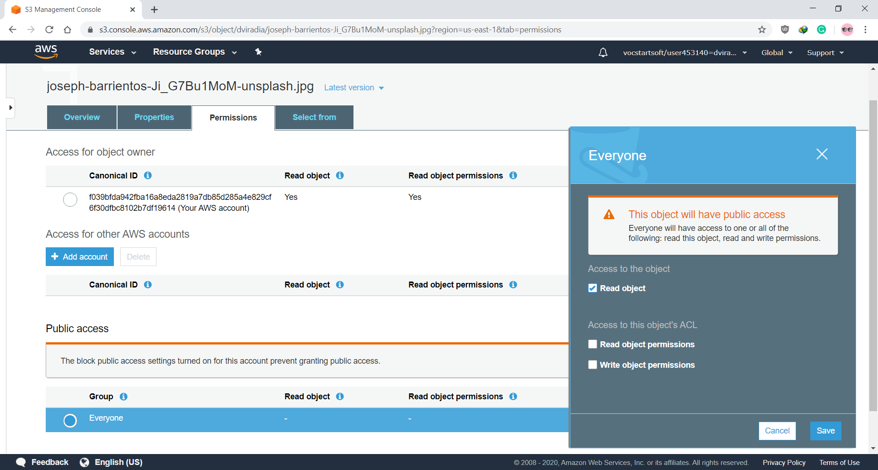

* Click on object URL on overview page to view your image

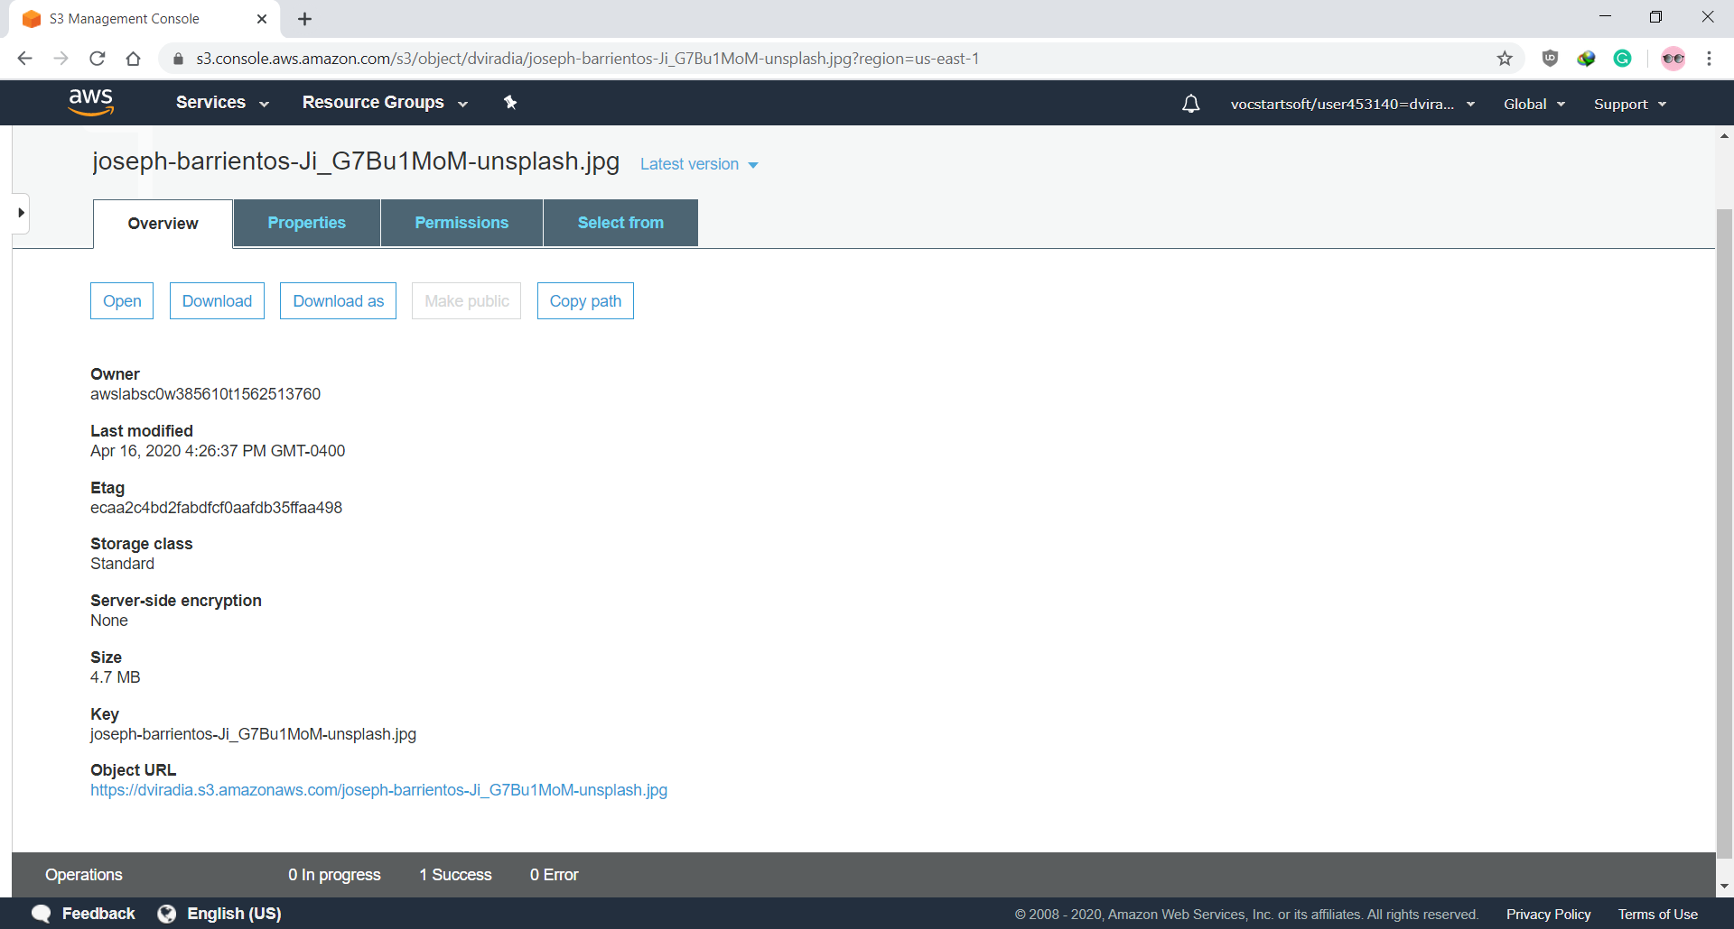

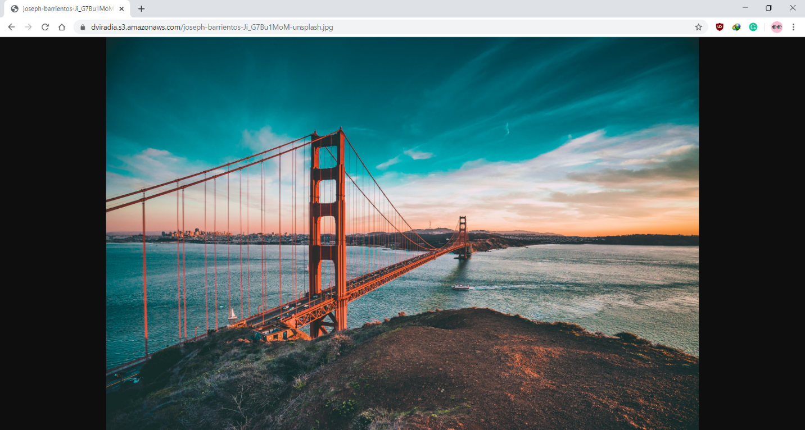

**Step for Creating an CloudFront Distribution**

* To create a CloudFront service go to AWS Dashboard and click on CloudFront

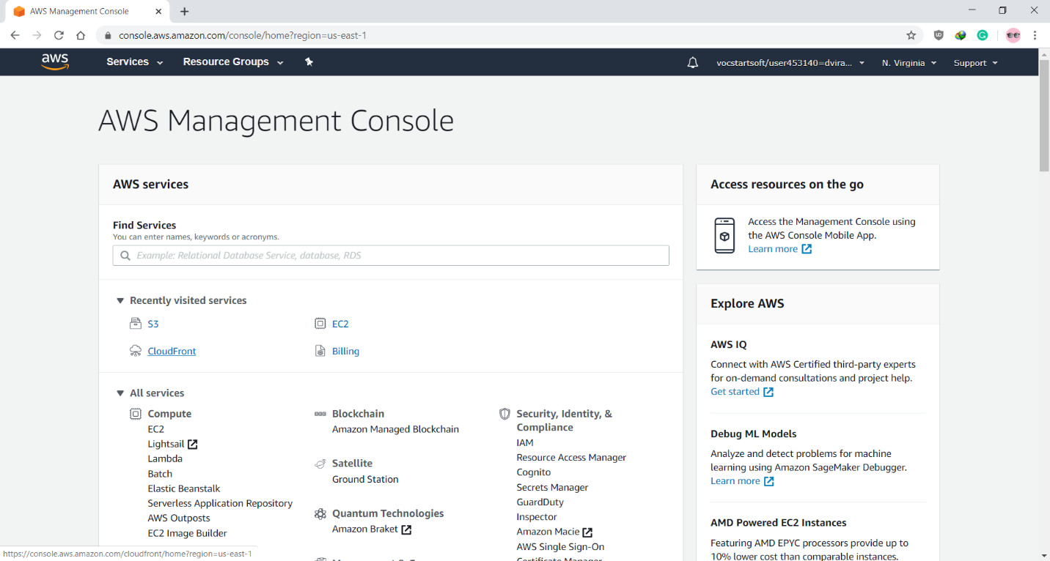

* Click on Create Distribution

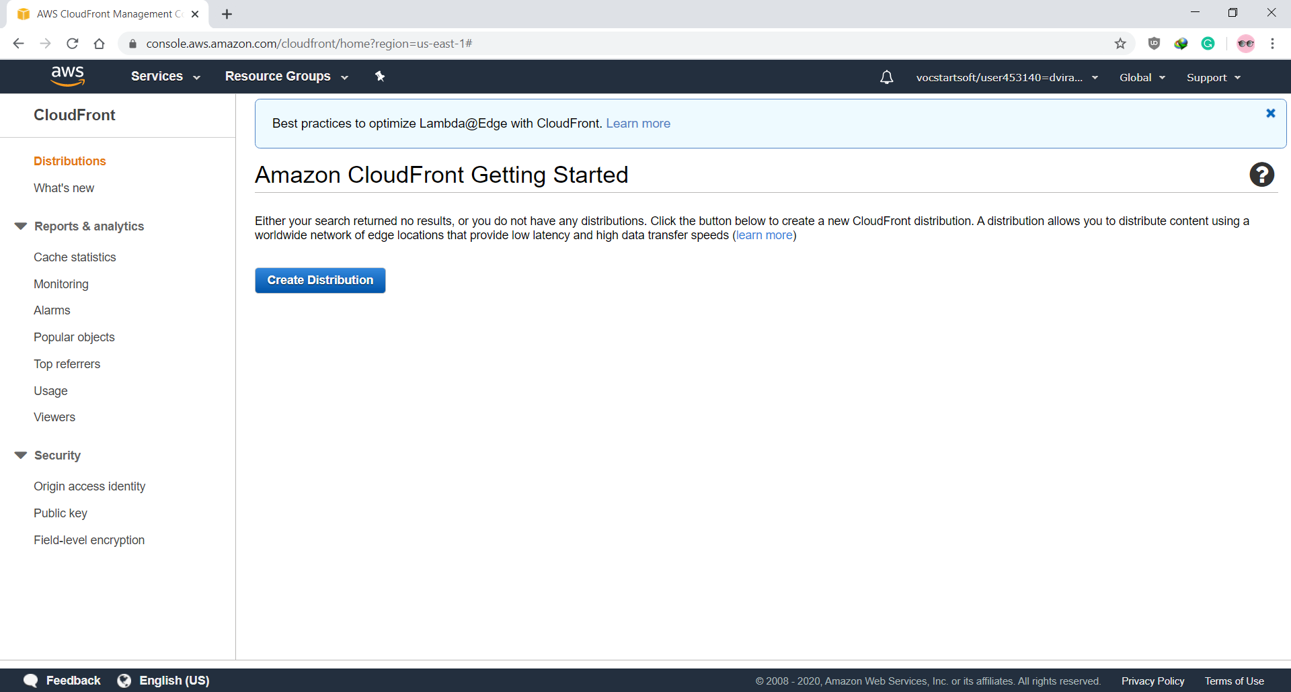

* Select Web Method

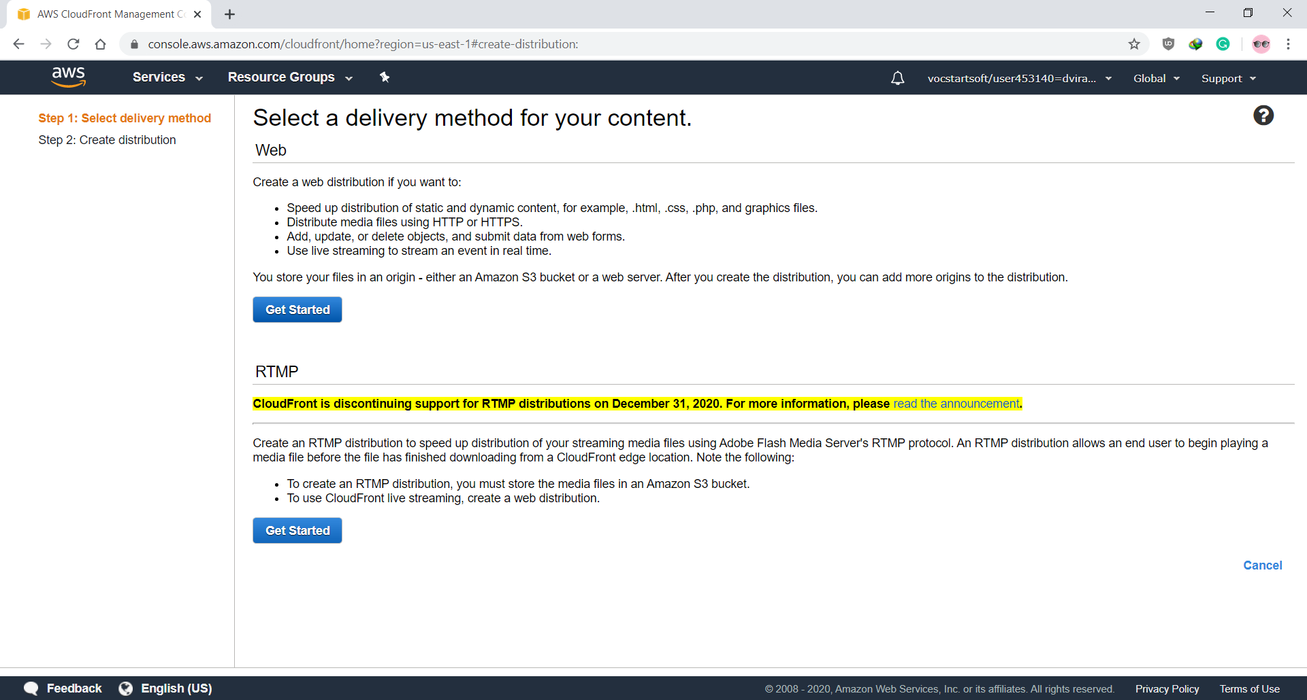

* Set origin Domain Name to your S3 bucket URL and restrict Bucket access

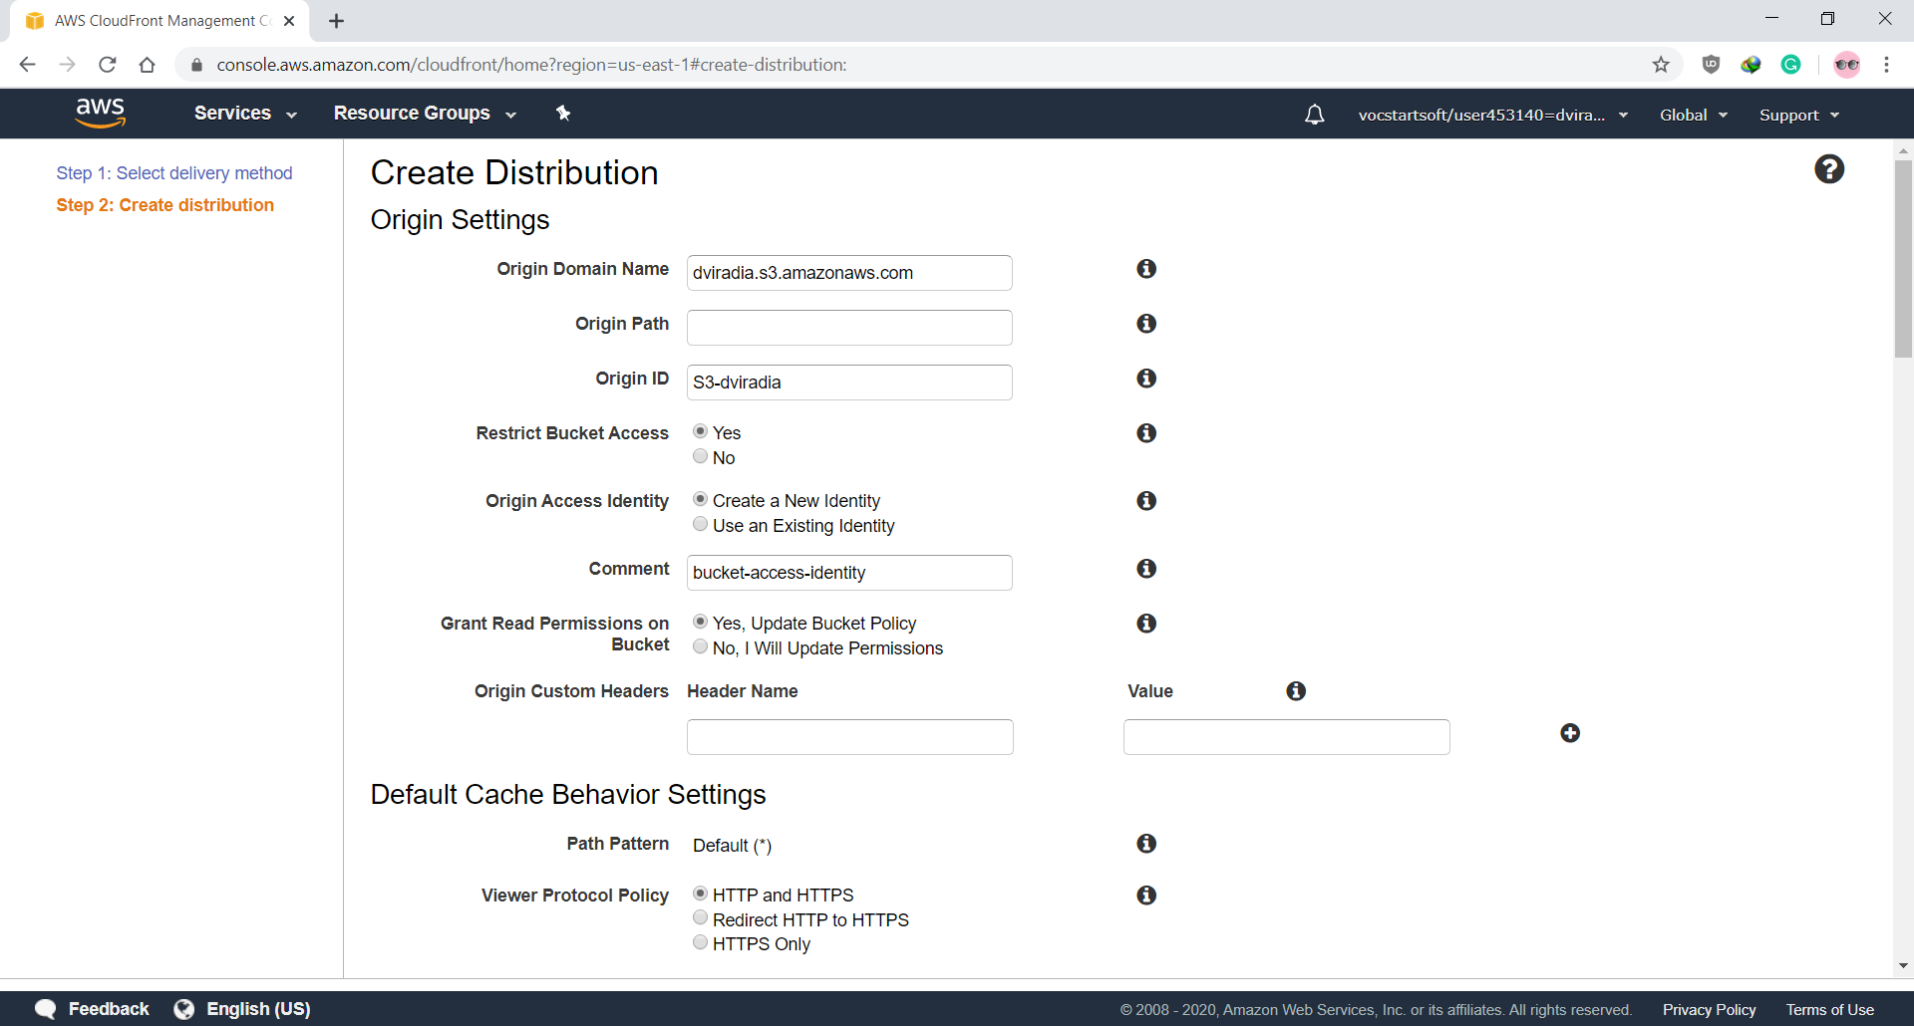

* Update other options as per preference, here I have set view protocol policy to redirect all http request to https and have created a log file for logging all the requests

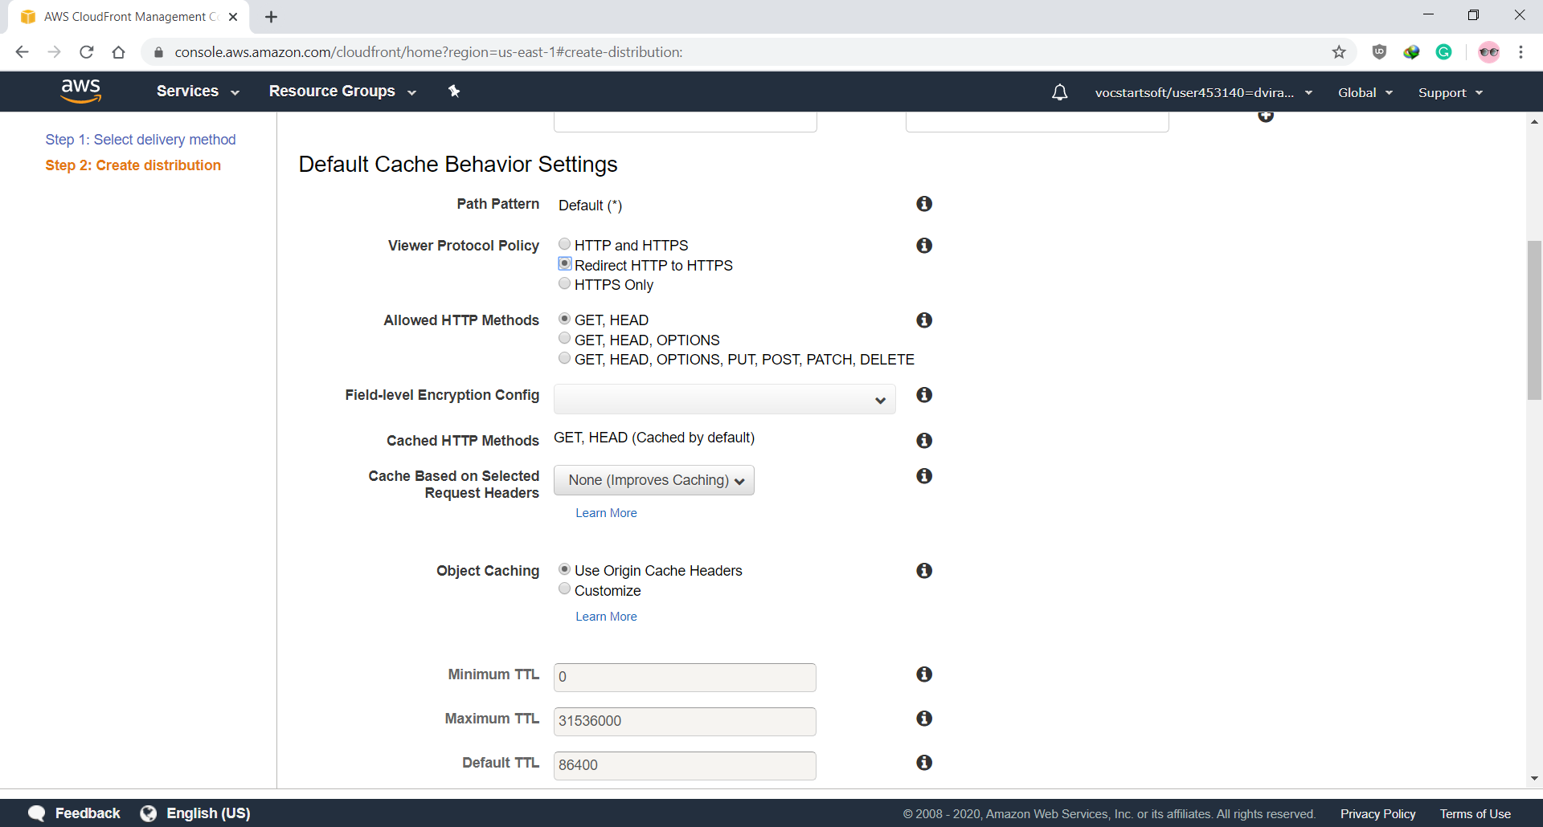

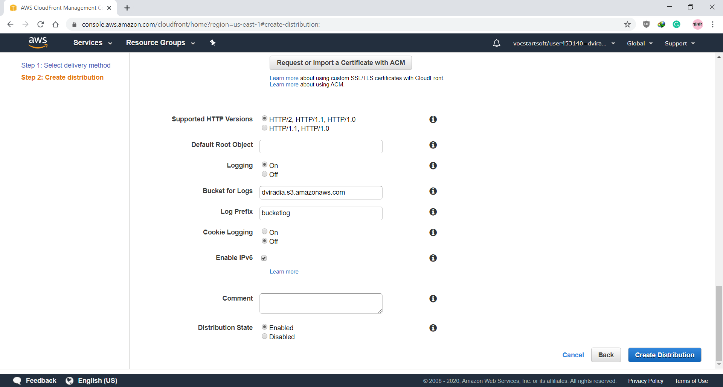

* Created Cloud distribution is available on the CloudFront Dashboard

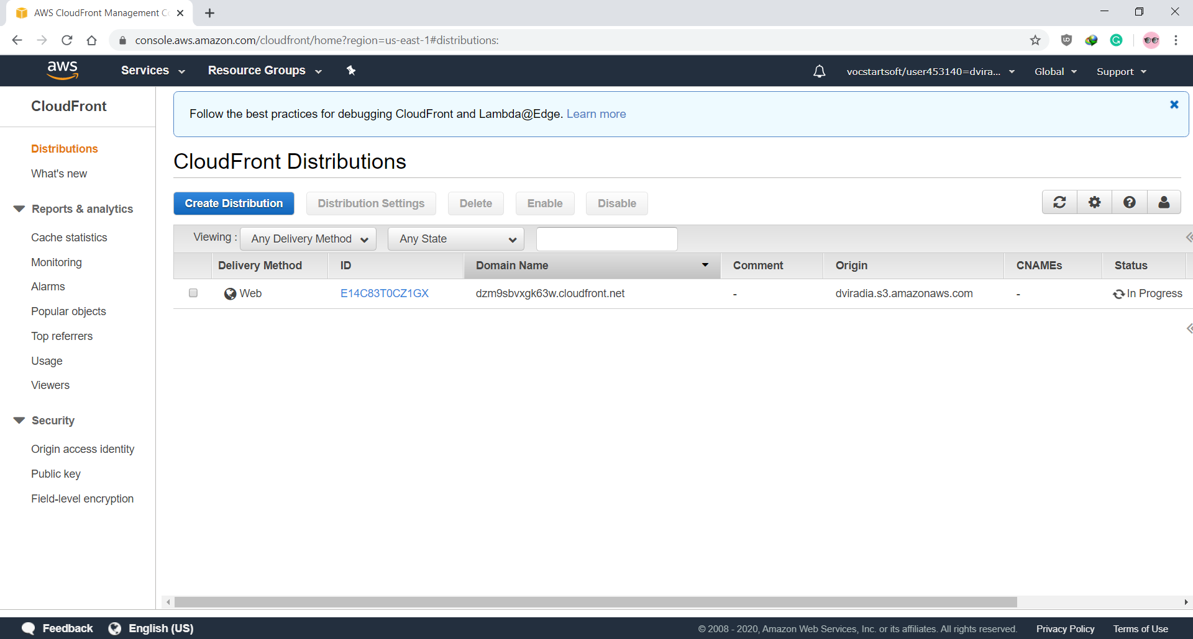

* Now go to S3 Console and disable all public access to the bucket

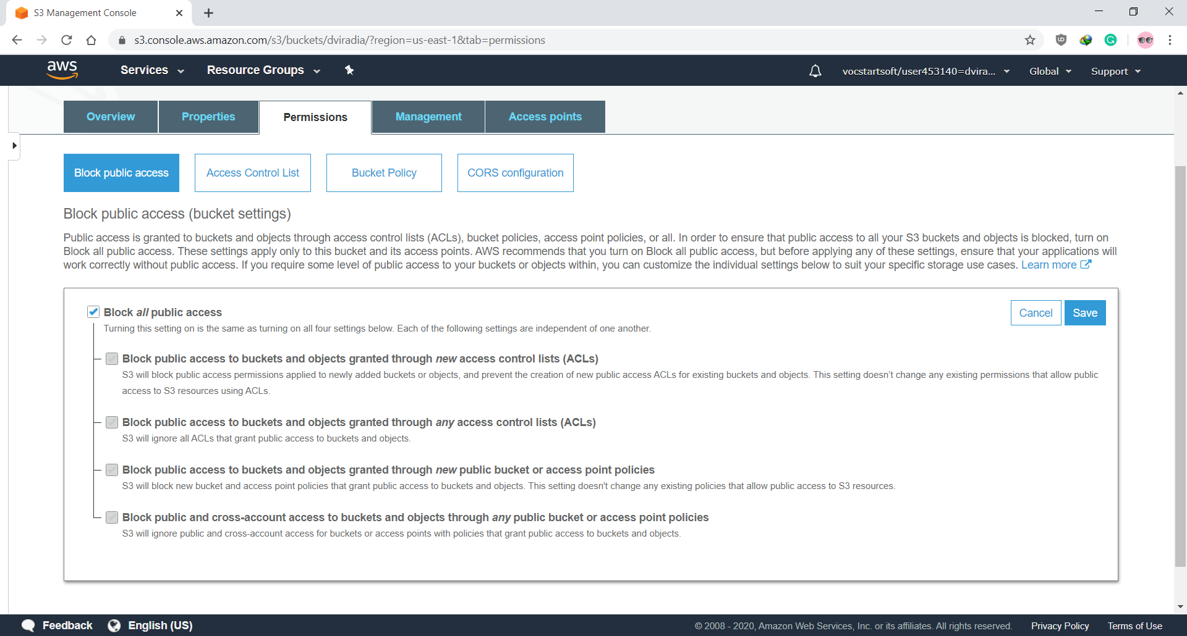

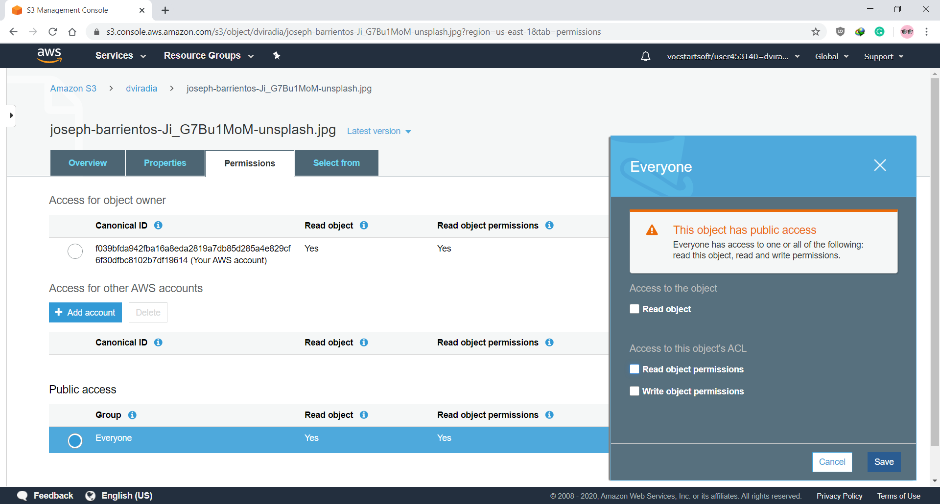

* Click on object URL and access to file should be denied

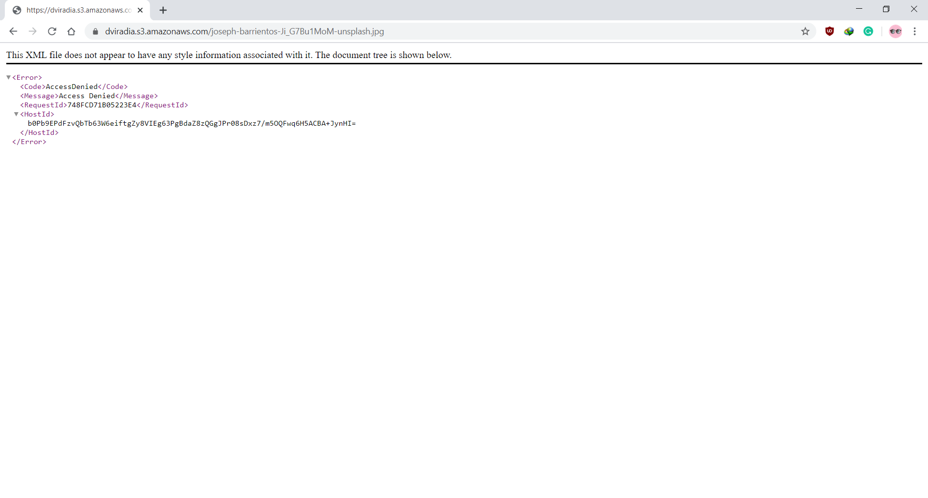

(The access to file is denied because the public access to file was revoked to view or manage file access key and secret key would be required)

* To view files now we have to replace S3 bucket address with CloudFront distribution address

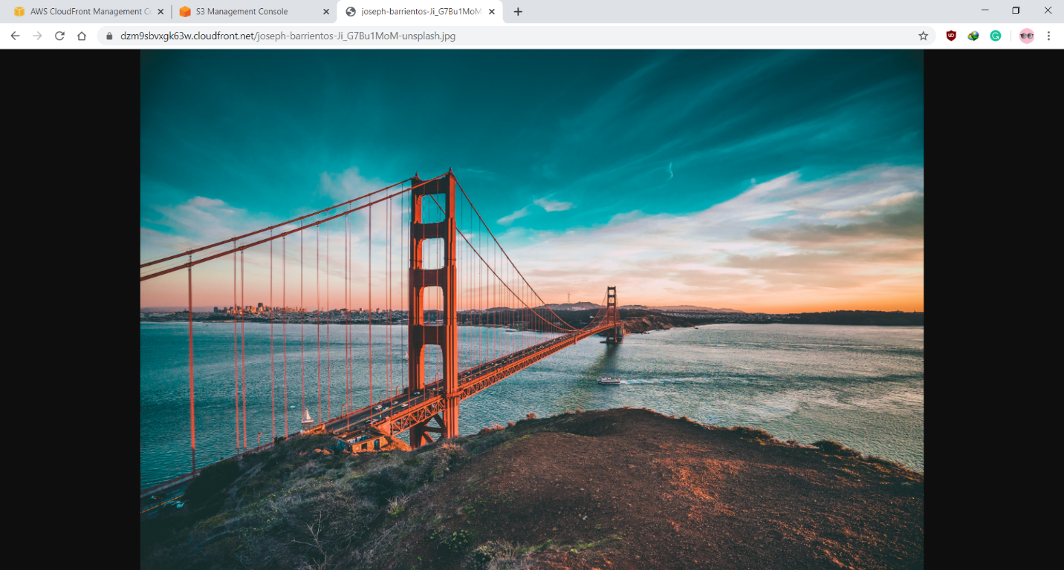

* All logs to CloudFront Distribution are saved to S3 bucket as configured

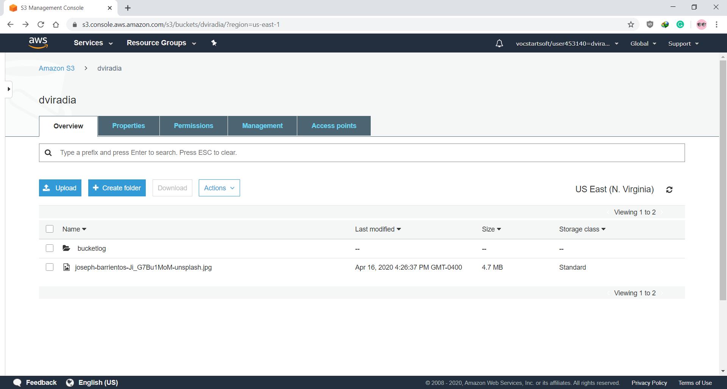

Image from CDN load significantly faster as compared to S3 bucket link

**The Benefits of using CDN:**

1. Different domains

Browsers limit the number of concurrent connections (file downloads) to a single domain. Most permit four active connections so the fifth download is blocked until one of the previous files has been fully retrieved. You can often see this limit in action when downloading many large files from the same site.

CDN files are hosted on a different domain. In effect, a single CDN permits the browser to download a further four files at the same time.

2. Files may be pre-cached

jQuery is ubiquitous on the web. There’s a high probability that someone visiting your pages has already visited a site using the Google CDN. Therefore, the file has already been cached by your browser and won’t need to be downloaded again.

3. High-capacity infrastructures

You may have great hosting but I bet it doesn’t have the capacity or scalability offered by Google, Microsoft or Yahoo. The better CDNs offer higher availability, lower network latency and lower packet loss.

4. Distributed data centers

If your main web server is based in Dallas, users from Europe or Asia must make a number of trans-continental electronic hops when they access your files. Many CDNs provide localized data centers which are closer to the user and result in faster downloads.

5. Built-in version control

It’s usually possible to link to a specific version of a CSS file or JavaScript library. You can often request the “latest” version if required.

6. Usage analytics

Many commercial CDNs provide file usage reports since they generally charge per byte. Those reports can supplement your own website analytics and, in some cases, may offer a better impression of video views and downloads.

7. Boosts performance and saves money

A CDN can distribute the load, save bandwidth, boost performance and reduce your existing hosting costs — often for free.